[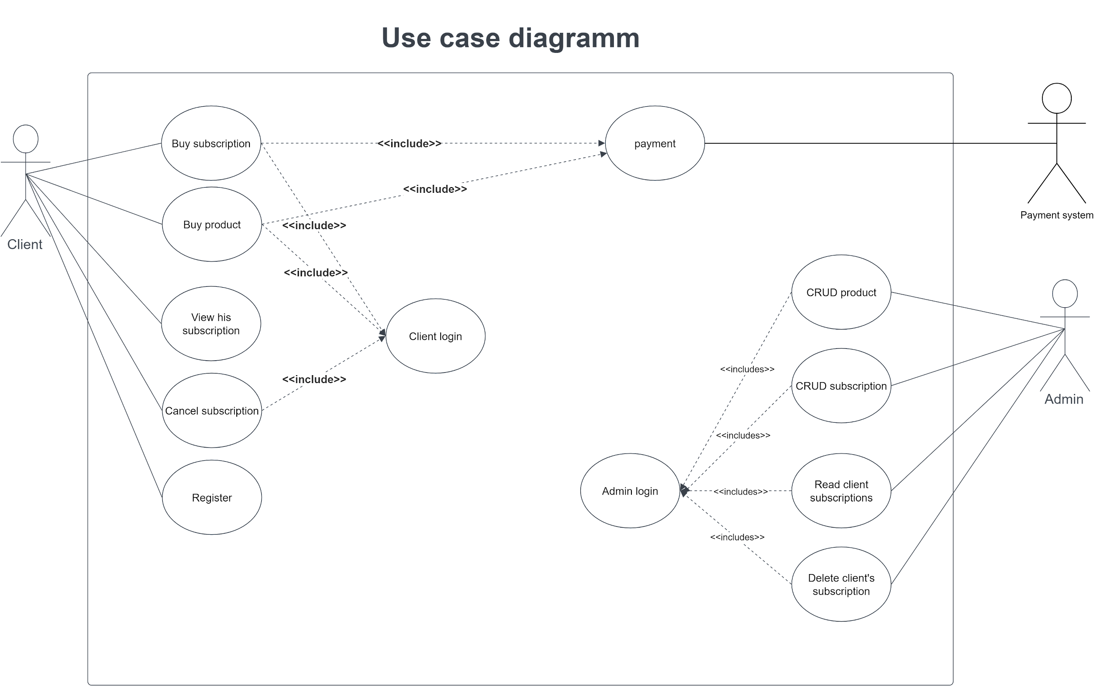](https://app.diagrams.net/?page-id=XB9d7JvffJFNSHc2OYXf&scale=auto#G1-c7-YQI4d2lFKhHOCo_wu_oXTLi4ubo2)

[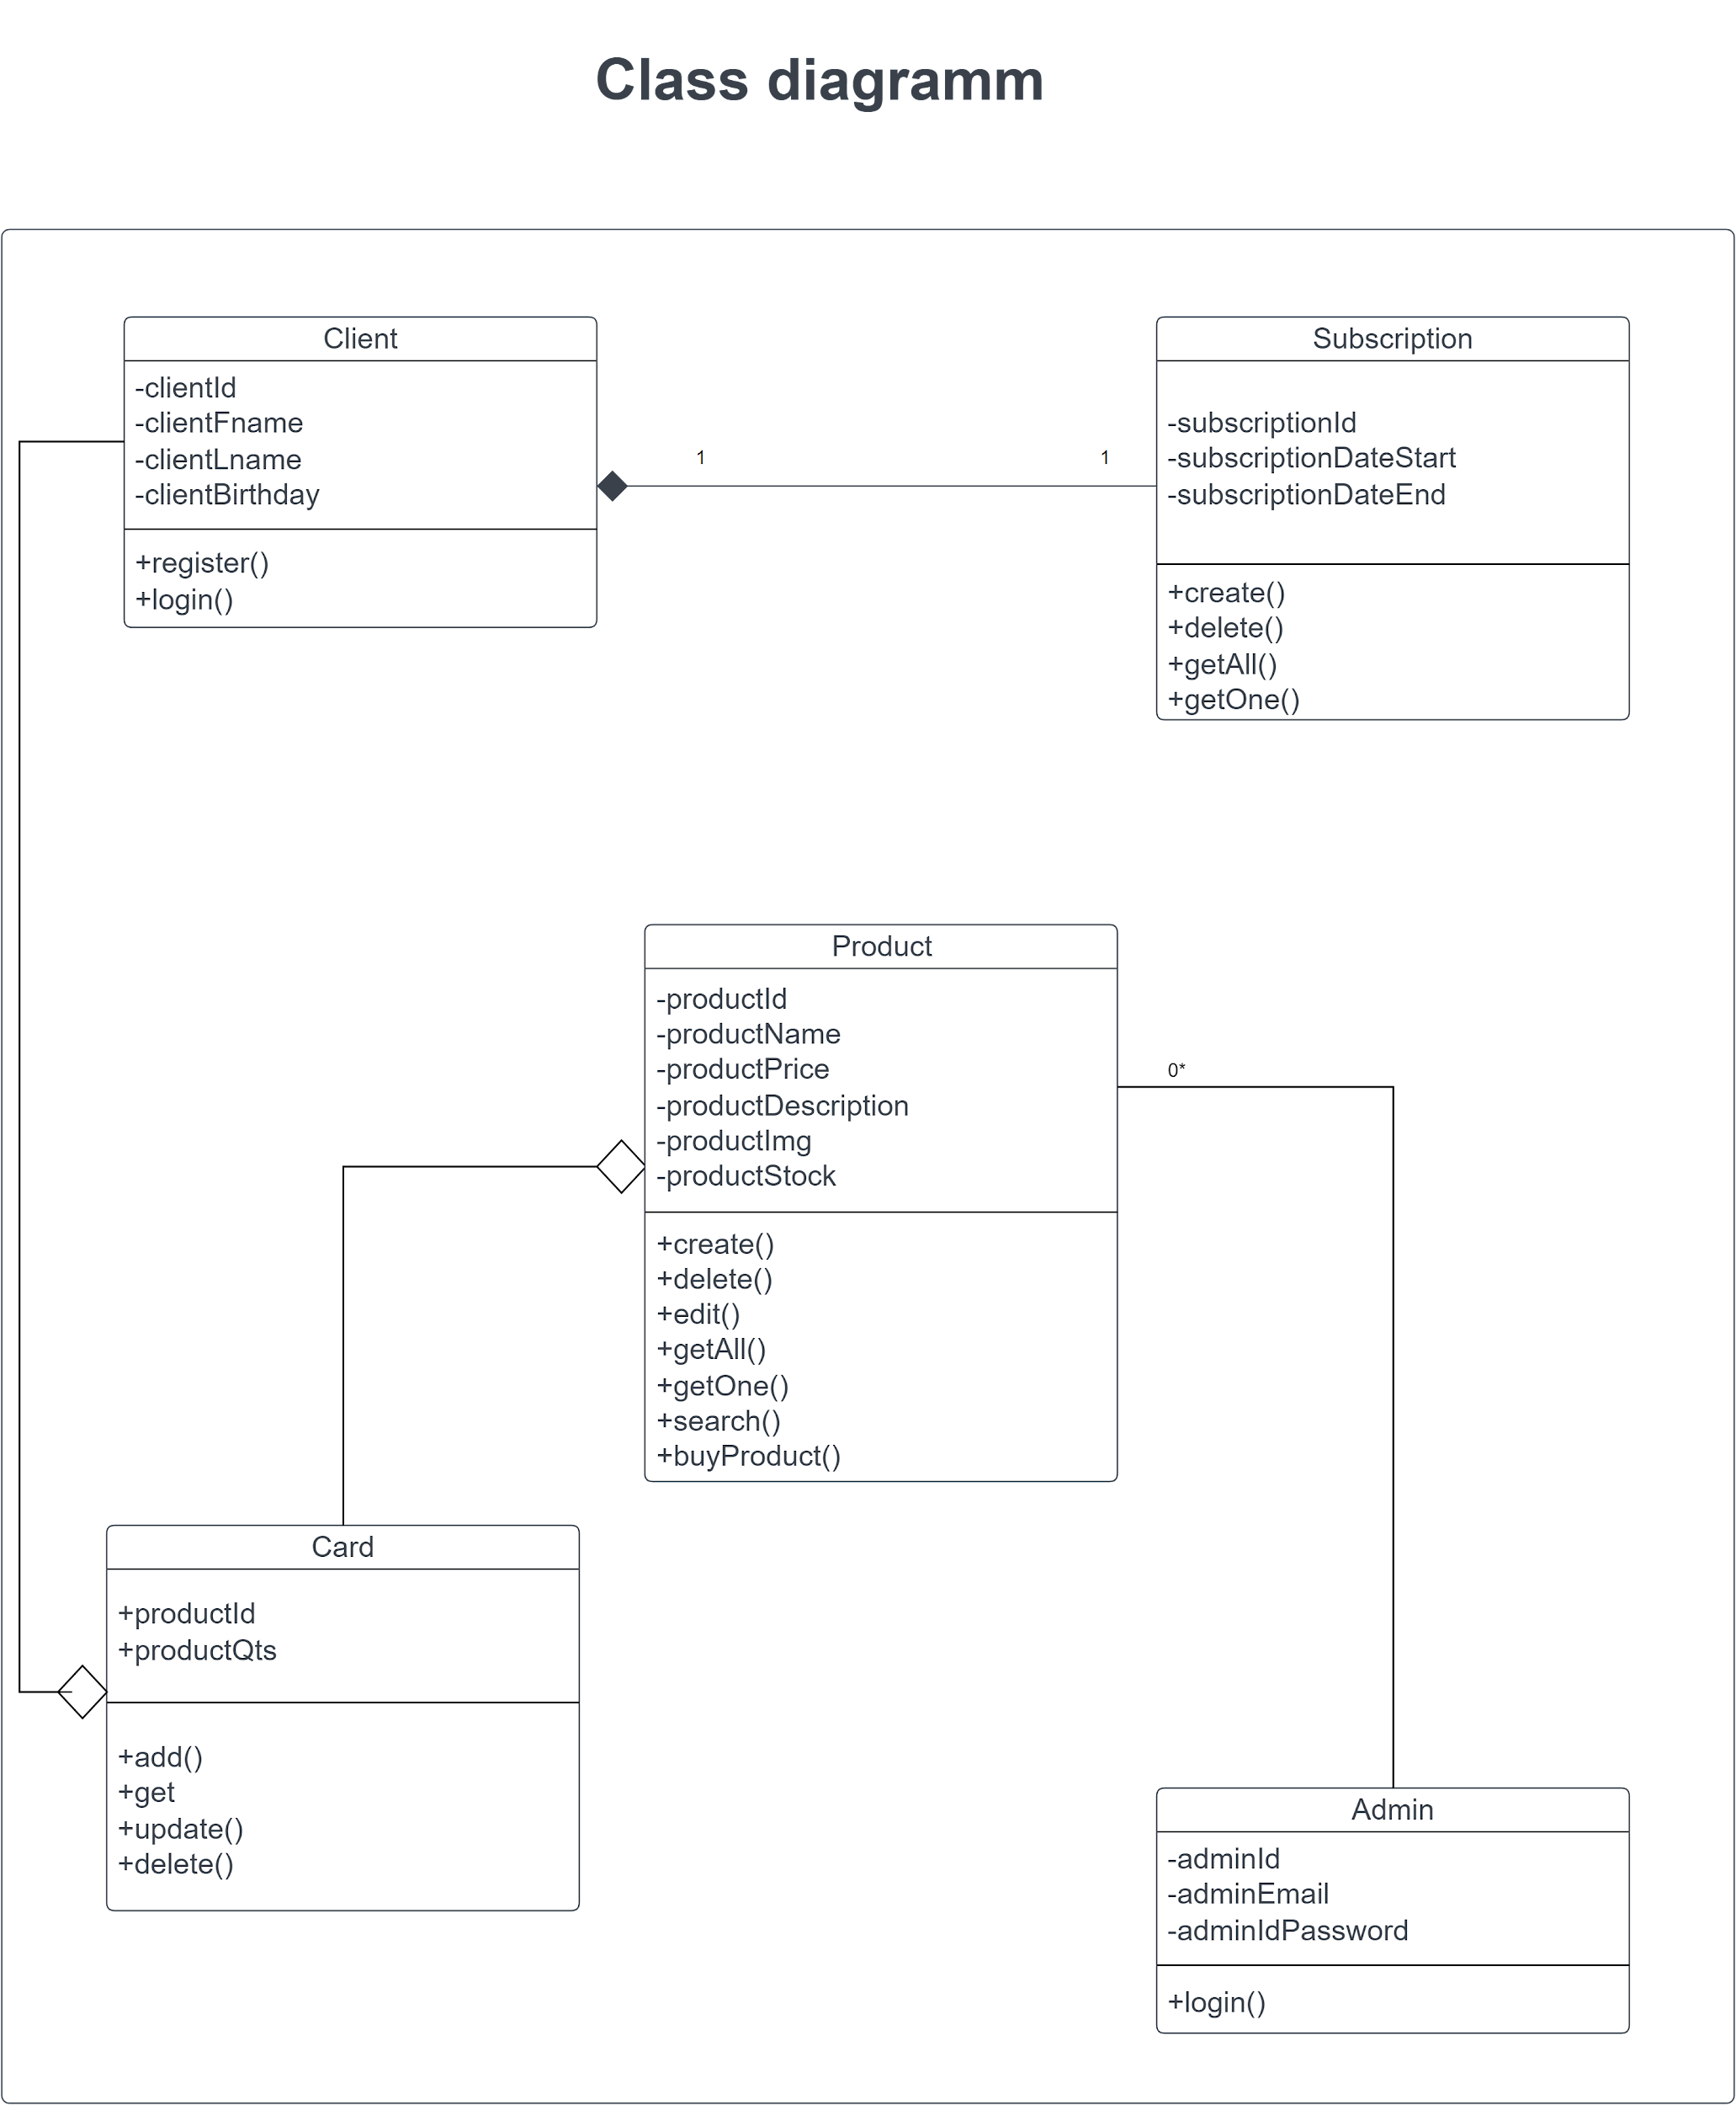](https://app.diagrams.net/?page-id=C5RBs43oDa-KdzZeNtuy&scale=auto#G1C7uwyzb55tYqSh7aqiNvZbA5OcVps645)

[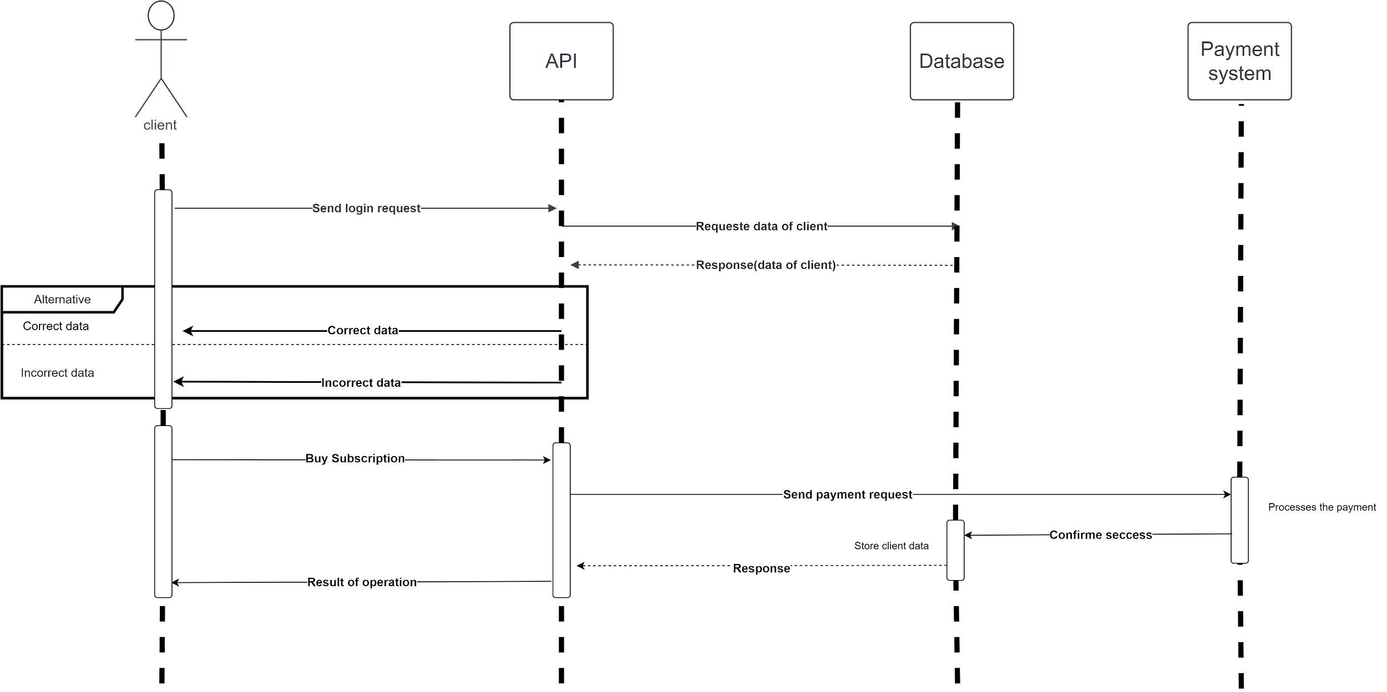](https://app.diagrams.net/?page-id=S8uU_IqLk2BTrHHwS8S4&scale=auto#G1KSwoqKt-oFQ5qNEv4nax6KaGInCaEOzO)

[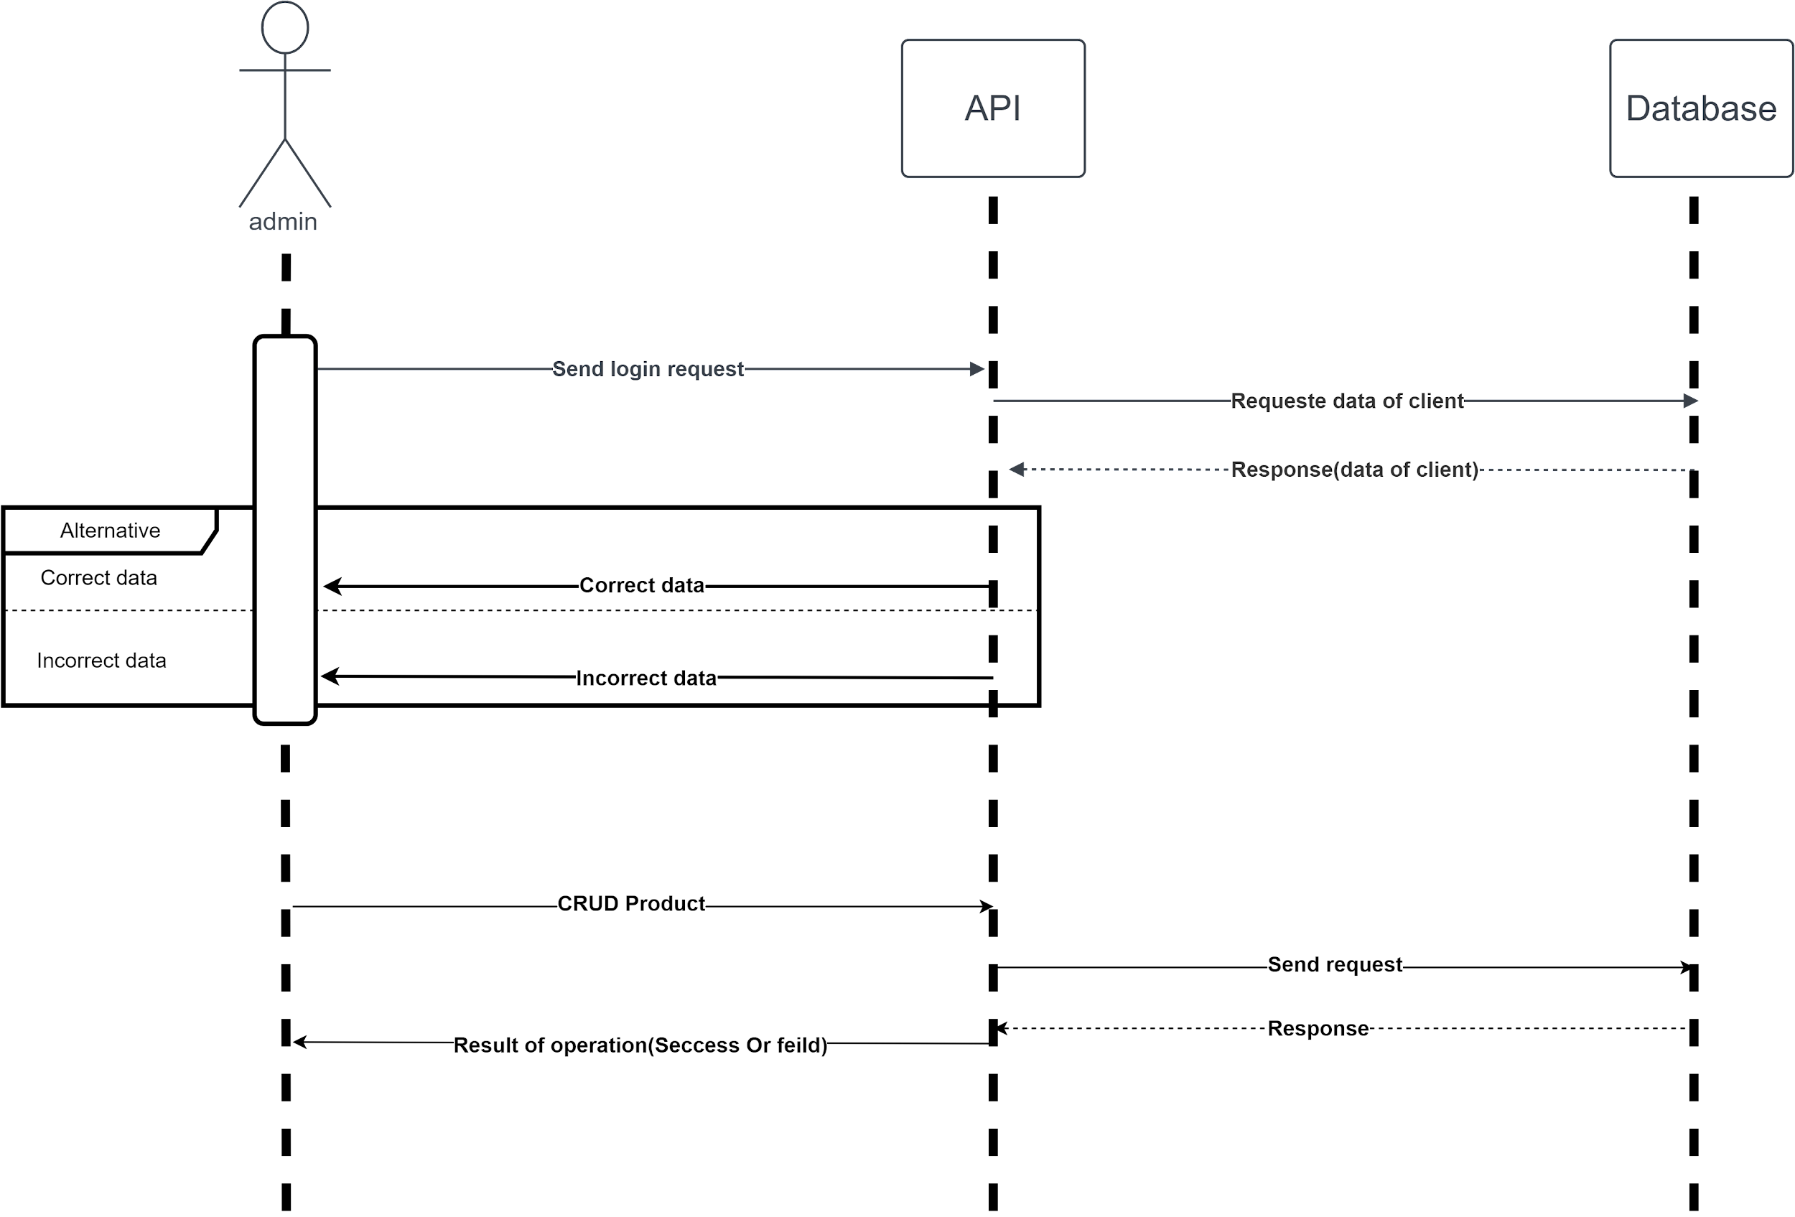](https://app.diagrams.net/?page-id=8jy0DxG-U-2RaiiY821L&scale=auto#G1IAXyieDpJHz2Y25aFyCvYwgKjylne_4Z)